**TIẾT 1- UNIT 2: LANGUAGE FOCUS**

**GRAMMAR (NGỮ PHÁP)**

**SIMPLE FUTURE TENSE: THÌ TƯƠNG LAI ĐƠN**

1. **Ý nghĩa: diễn tả 1 hành động sẽ xảy ra ở tương lai**

**2. Công thức:**

* Affirmative (câu khẳng định): - S+ **will (sẽ)+ V0**

- Example:+She **will eat** bread for breakfast (bữa sáng).

+They **will eat** bread for breakfast.

* Negative (phủ định): - S+ **won’t (will not) + V0**… (won’t: sẽ không)

- Example: +She **won’t eat** bread for breakfast.

+They **wont eat** bread for breakfast.

* Câu hỏi Yes/ No - **Will** + S+ **V0**…? 🡪**Yes**, S + **will**./ **No**, S + **won’t**.

- example: +**Will** she **eat** bread for breakfast?

🡪 **Yes**, she **will**/ **No**, she **won’t**.

+**Will** they **eat** bread for breakfast?

🡪 **Yes**, they **will** / **No**, they **won’t**.

* Wh- Question (câu hỏi với từ để hỏi Wh): - **Wh-Q**+ **will** + S+ **V0**….?

- Example: +**What will** she **eat** for breakfast?

🡪 She will eat bread for breakfast.

+**What will** they **eat** for beakfast?

🡪 They will eat bread for breakfast.

**3. Dấu hiệu nhận biết thì hiện tại đơn**: trong câu có các trạng từ  **tomorrow** (ngày mai)**; some day** (1 ngày nào đó)**; in the future** (trong tương lai)**; next month** (tháng sau)**, next week** (tuần sau)**, next year** (năm sau)

**Exercise: Supply the simple future for the verbs in parenthesis (chia thì tương lai cho động từ trong ngoặc)**

1. I ­______________ (give) Lan (a.) doll on her birthday.

2. What game______________ you______________ (play) on her Lan’s birthay?

3. The birthday party ______________ (start) at five o’clock and ______________ finish at nine.

4. Lan ______________ (be) 13 on Sunday, May 25th .

5. She ­______________ (invite) some of her friends.

6. Hoa ______________ (not be) happy because she doesn’t have any friends.

7. In the future, I ­______________ (become) a doctor.

8. ______________ Lan ______________(be) 13 on her next birthday.

**PREPOSITIONS (CÁC GIỚI TỪ)**

* **on + days (sau on+ ngày, *tất cả từ chỉ thời gian có ngày*)**

Ex: on Monday, on Wednesday, on her birthday, on May 25th, …)

* **in+ months (sau in + tháng)**

Ex: in May, in July, in September, …

* **in+ year (sau in+ năm)**

Ex: in 2021, in July 2021, …

* **at + time (sau at+ giờ)**

Ex: at five o’clock, at 9:45, at ten,..

* **at + địa chỉ nhà**

Ex: at 12 Tran Hung Dao Street

**Exercise: Fill in the blank with a correct preposition: (điền giới từ phù hợp)**

1. Viet lives ________ his uncle and aunt.

2. Her birthday is ______________ October 17th.

3. Our party will be ___ ten o'clock to half past eleven___ the morning___ Sunday.

4. Trung will have a party ________ her birthday _______ home.

5. They often go swimming ______ Sunday.

6. We are playing chess _____________ the moment.

7. It often rains ________ July.

**REIVIEW UNIT 2**

1. **Choose the word or phrase (A, B, C, or D) that best fits the blank space in each sentence.**
2. __________ is your telephone number?

A. When B. Which C. What D. Why

1. Nga lives ________ 52 Nguyen Dinh Chieu street.

A. at B. on C. in D. by

1. Her birthday party is _______ Friday, August 20th

A. at B. on C. in D. by

1. ________ you have a test tomorrow morning?

A. Will B. do C. are D. does

1. __________ is your brother?

A. How age B. What age C. How old D. B&C are correct

1. Nhat _______ 9 years old on his next birthday

A. is B. will C. will be D. isn’t

1. When's your ______?

A. birthday B. day of birth C. date of birth  D. birthdate

1. Ba: Will he be free on Sunday? Nam:______

A. A. No, he won't B. No, he doesn't C. No. he isn't  D. No, he will

1. White is the color Hoa likes ____________.

A. most B. good  C. favorite D. more than

1. What's your ______?

A. date of birth B. birthdate C. birthday  D. day of birth

1. An: Will you be free tomorrow evening? Hoa: ______

A. Yes, I will B. Yes, I do C. Yes, I am  D. Yes, I won't

1. Ba: Where will we meet? -Nam:______ the movie theater.

A. In front B. Next C. In front of  D. Before

1. When does our new school year begin ? –It’s in ___________.

A August B. September, 5th C. Monday, September D. Thursday

1. Lan will _______some of her friends to her birthday party.

A. tell B. meet C. invite D. see

1. The party will start at 6.00 P.M and_______ at 9.00 P.M

A. finish B. finishes C. finishing D. to finish

1. **Use the correct word form given in each sentence**
2. Orange juice is ____________________________ than coffee. (good)
3. I’m ____________________ _____ in playing tennis .( interest)
4. May I ask you a _____________________________ question? (person)
5. She will invite some of her __________________ to her birthday party. (friendly)
6. Please ____________ me when there are test results. (information)
7. Lan is writing some_____________ cards for her birthday now. (invite )
8. Would you like to join us to Lan’s _______________party? (birth)
9. Why is Hoa _______________? (worry)
10. **Choose the word or phrase that best fits the blank in the following passage.**

**❖1**. Hi, I am Thanh. I live with my family in a small town near Hanoi. My parents are (24) ________ and they work in a factory (nhà máy). Every day they go to the factory early in the morning and come back in the afternoon. They go to work (25) ________ motorbike. My school is not far from my house, so I often go to school (26) __________ foot. I often cook dinner and do the (27) ____________ to help my parents. Sometimes I go (28) ________ with my mother. I have an (29) ________ brother. He’s Hung, and he studies at National University.

1. A. workers B. worker C. teachers D. farmers
2. A. on B. by C. at D. in
3. A. on B. at C. in D. by
4. A. housework B. homework C. exercise D. houseworks
5. A. shop B. shopped C. shopping D. shops
6. A. elders B. olders C. old D. elder

**2**. My name is Nam . I live (30)__________ my parents in Ho Chi Minh city . I have (31) __________ friends at school . My telephone number (32) _________ 348684395. I often (33) ___________ on the telephone. Now I am calling to my classmate to (34) _________ them to my birthday party. My birthday is (35) _______October 22nd, I will have my birthday party at home. The party will start at six o’clock and finish at eight.

1. A. with B. in C. at D. on
2. A. many B. a lot of C. lots of D. All are correct
3. A. are B. has C.is D. have
4. A. talk B. meet C. play D. listen
5. A. miss B. finish C. invite D. join
6. A. in B. on C. at D. from
7. **Read the passage and decide whether the statements are True or False:**

**❖1**. Her name is Celia. She lives with her parents in Cambridge. Her address is 10 Station Road. Her telephone number is 8 262 387. She will be thirteen on her next birthday. It’s on Sunday, April 24th. She will have a small party for her next birthday. She will invite some of friends to her house. They will eat cakes and ice – cream. And they will have a lot of fun. Tonight, she will plan her party. At the moment, she is writing some invitations.

1. Celia’s birthday is on March 14th………………..
2. She lives with her father and her mother……………..
3. Her address is 10 Station Road……………….
4. She is writing a letter………………

**2.** Her name is Hoa .She works in a large company in Ho Chi Minh City. She is a secretary (thư kí). Every day, she answers the phone and also uses a computer a lot. She has to speak English with her boss .She starts work at 8.00.Hoa usually rides a motorbike to work .She has lunch at 12.00 .She finishes work at 5.30. She goes homes and helps her mother cook dinner .After dinner she often watches television for a while and reads books. She usually goes to bed at 11.00 pm.

1. Hoa’s daily jobs at work are using a computer and talking on the phone …………..
2. She speaks English with her mother …………
3. She goes to work by motorbike …………..
4. She often helps mother at home after dinner …………..

**THE END**

**Tiết 2- Unit 3: AT HOME**

**A. What a lovely home!**

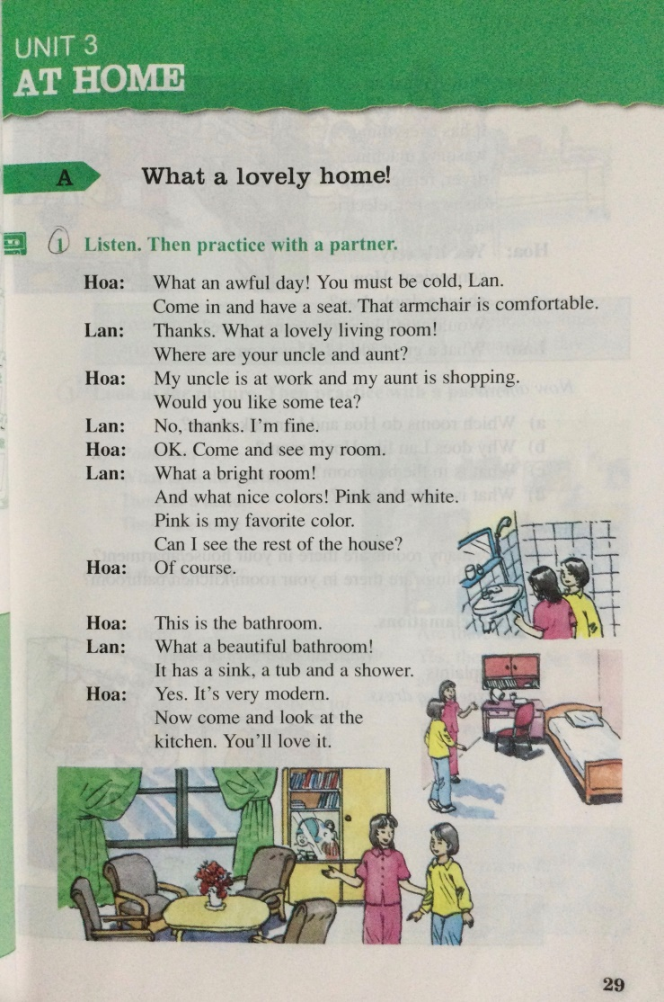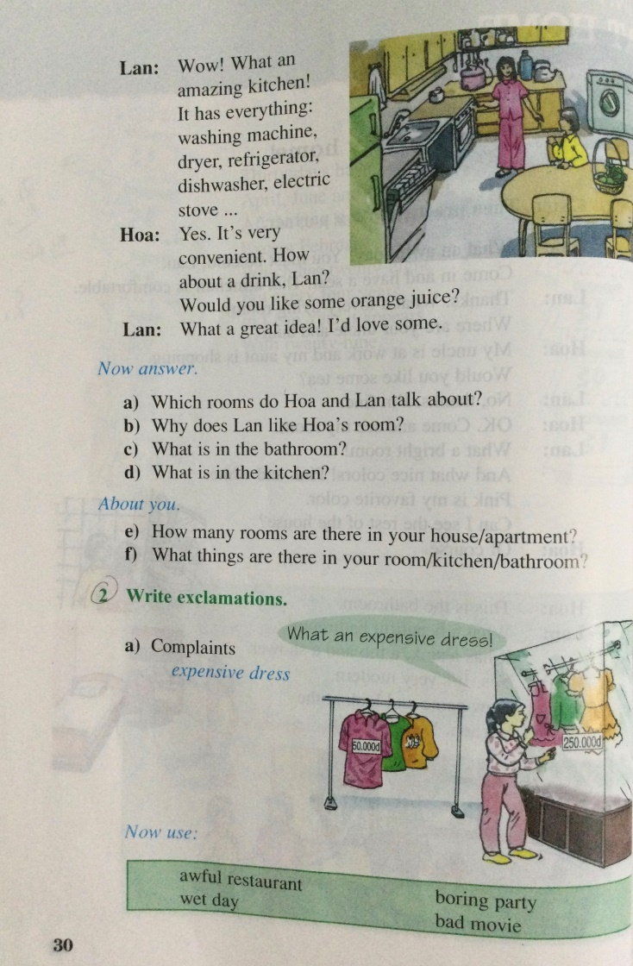

**Vocabulary:**

|  |  |  |
| --- | --- | --- |
| Word | Picture | Meaning (nghĩa) |
| 1. awful (a.)= bad (a.): |  | tồi tệ, tệ |
| 2. Must be (v.): |  | chắc hẳn |
| 3. have a seat: |  | ngồi đi |
| 4. armchair (n.): |  | ghế bành |
| 5. comfortable (a.):  🡪 comfort (v.) (n.): |  | thoải mái |
| 6. lovely (a.):  🡪 love (v.) (n.): |  | đáng yêu  yêu, tình yêu |
| 7. bright (a.): |  | tươi sáng |
| 8. favorite (a.)  🡪 favor (v.) (n.): |  | yêu thích, ưa thích  yêu thích |
| 9. the rest of : |  | phần còn lại |
| 10. beautiful (a.):  🡪 beauty (n.): |  | xinh đẹp  sắc đẹp |
| 11. Sink (n.) |  | Bồn rửa tay |
| 12. tub (n.) |  | Bồn tắm |
| 13. shower |  | Vòi sen |
| 14. modern (a.) |  | Hiện đại |
| 15.amazing (a.)  🡪 amaze (v.) |  | Tuyệt vời  Làm ngạc nhiên |
| 16. washing machine |  | Máy giặt |
| 17. dryer (n.) |  | Máy sấy tóc |
| 18. refrigerator (n.) |  | Tủ lạnh |
| 19. electric stove |  | Bếp điện |

**GRAMMAR**

**1. Exclamation with What (**Câu cảm thán với **What)**

**+ With count Nouns** (Với danh từ đếm được)

* What + a/an + Adjective + Noun (số ít)!

What a beautiful Christmas tree! (Cây giảng sinh đẹp quá!)

What an interesting film! (Phim hay quá!)

* What + Adjective + Noun (Số nhiều)!

What difficult exercises! (Những bài tập khó quá!)

**+ With Non-count Nouns** (Với danh từ không đếm được)

What + Adjective + Noun!

What hot weather! (Thời tiết nóng quá!)

**2. Exclamation with How** (Câu cảm với **How**)

How + Adjective + Noun+ be!

How beautiful the princess is! (Công chúa đẹp làm sao!)

**Exercise: Rewrite**

**Dạng câu cảm thán : What+ (a/an)+ adj+ N!**

**⬄ How+ adj+ N+ be!**

1. How big the house is !

What a ________________________________________________________________

1. The weather is very cold

What

1. The weather today is very nice

What _________________________________________________________________

1. The movie is interesting.

What an

1. How delicious dinner is!

What a

6. The house is so lovely!

What a